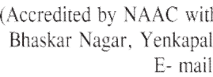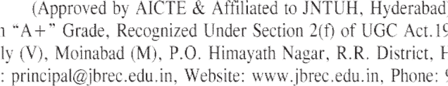

EXAMINATION BRA NCH

I YEAR B. TECH – I SEMESTER – R25 REGULATION – 2ND MID TERM EXAMINATIONS JANUARY- 2026
TIME: 10.00 AM to 12.00 (noon)

BRANCH | DATE, SESSION AND DAY
BRANCH | 05-01-2026  Monday | 06-01-2026  Tuesday | 07-01-2026  Wednesday | 08-01-2026  Thursday | 09-01-2026  Friday
BRANCH | 10.00 AM TO 12.00 (noon)
02-EEE (16) | Matrices and Calculus | Advanced Engineering Physics | Programming for Problem Solving | Electrical Circuits-I | English for Skill Enhancement
03-ME (12) | Matrices and Calculus | Advanced Engineering Physics | C Programming and Data Structures | Engineering Mechanics | English for Skill Enhancement
04- ECE (67) | Matrices and Calculus | Advanced Engineering Physics | Programming for Problem Solving | Basic Electrical Engineering | English for Skill Enhancement
66 - CSE (AI&ML) - (171) | Matrices and Calculus | Advanced Engineering Physics | Programming for Problem Solving | Basic Electrical Engineering
12 – IT - (40) | Matrices and Calculus | Engineering Chemistry | Programming for Problem Solving | Basic Electrical Engineering
TIME : 01.30 to 03.30 PM (AN)

BRANCH | DATE, SESSION AND DAY
BRANCH | 05-01-2026  Monday | 06-01-2026  Tuesday | 07-01-2026  Wednesday | 08-01-2026  Thursday | 09-01-2026  Friday
BRANCH | 01.30 PM TO 03.30 PM
67 – CSE (DS)  (61) | Matrices and Calculus | Advanced Engineering Physics | Programming for Problem Solving | Basic Electrical Engineering
05 – CSE  (261) | Matrices and Calculus | Engineering Chemistry | Programming for Problem Solving | Electronic Devices and Circuits | English for Skill Enhancement

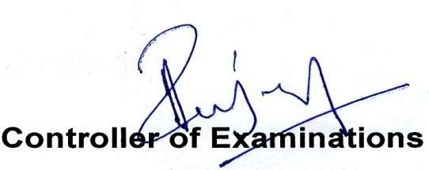

Copy to:
- All Deans 02.All H.O.D’s

03.InformationtoStudents.

PRINCIPAL

EXAMINATION BRA NCH

I YEAR B. TECH – I SEMESTER – R25 REGULATION – 2ND MID TERM EXAMINATIONS JANUARY - 2026

BRANCH | DATE, SESSION AND DAY
BRANCH | 10-01-2026 Saturday
BRANCH | 10.00 AM TO 12.30 PM
02-EEE (16) | Engineering Drawing and Computer Aided Drafting
12 – IT (40) | Engineering Drawing and Computer Aided Drafting
66 - CSE (AI&ML)  A Section | Engineering Drawing and Computer Aided Drafting

BRANCH | DATE, SESSION AND DAY
BRANCH | 10-01-2026 Saturday
BRANCH | 01.15 PM TO 03.45 PM
66 - CSE (AI&ML)  B and C Section | Engineering Drawing and Computer Aided Drafting

BRANCH | DATE, SESSION AND DAY
BRANCH | 12-01-2026 Monday
BRANCH | 10.00 AM TO 12.30 PM
04- ECE (68) | Engineering Drawing and Computer Aided Drafting

BRANCH | DATE, SESSION AND DAY
BRANCH | 12-01-2026 Monday
BRANCH | 01.15 PM TO 03.30 PM
67 – CSE (DS) (61) | Engineering Drawing and Computer Aided Drafting

Copy to:
- All Deans 02.AllH.O.D

03.InformationtoStudents.

